Chapter 6: Scatterplots, Association, and Correlation

1. **Scatterplot:**
2. Open the data file (Height and Weight.csv).
3. Select the variable height and weight.

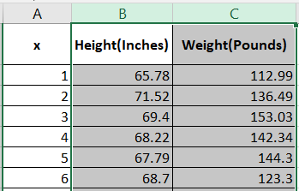

1. Select the **Insert** tab $⟹$**Insert Scatter Cart (X, Y) or Bubble Chart $⟹$ Scatter**.

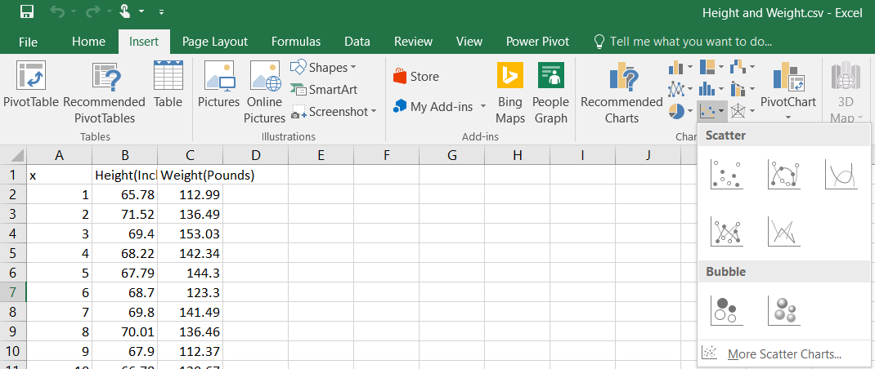

1. The result is

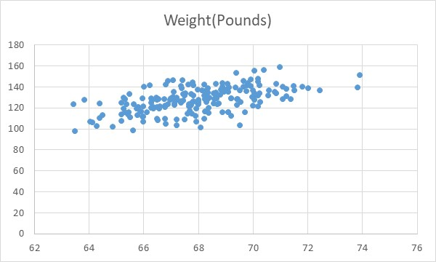

1. We can control the Y axis. Since the minimum is above 80, so double click on the Y axis, the **Format Axis** box will appear, then we replace the M**inimum** value.

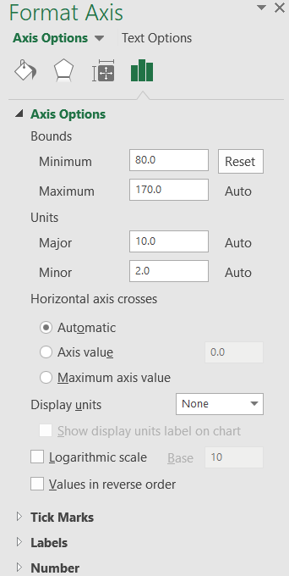

1. The result is

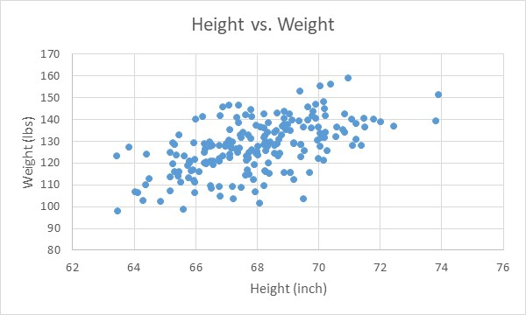

**Note:** we can set the graph title and X and Y axis labels. See Chapter 2 – Part 2.

1. **Correlation:**
   1. **Correlation using Data Analysis:**
2. Select the **Data** tab $⟹$**Data Analysis**.

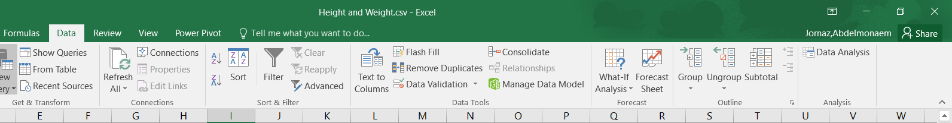

1. The **Data Analysis** box will appear, select **Correlation** and click **OK**.

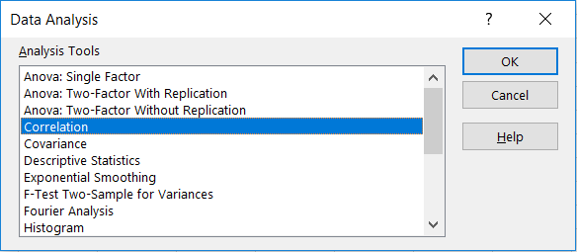

1. The **Correlation** box will appear. Click on **Input Range** and select range of the variables. Click on **Output Range** and select any empty cell to present the results on it, then click **OK**.

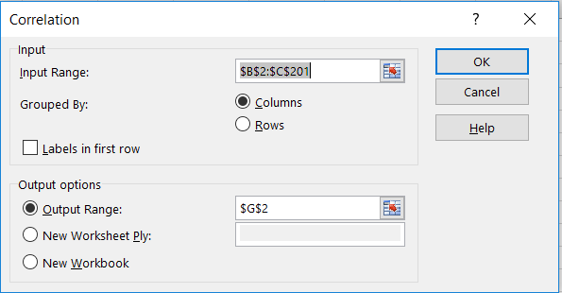

1. The result is

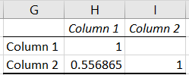

The correlation coefficient = 0.56

* 1. **Correlation using Formula:**

1. Select any empty cell, let’s say **G1**.
2. Select the **Formulas** tab $⟹$**More Function $⟹$ Statistical $⟹$** **CORRE**.

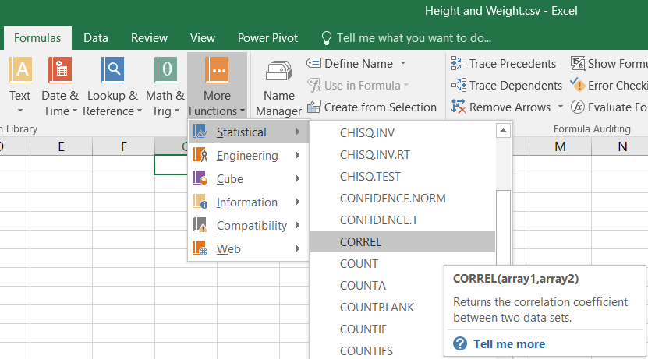

1. The **Function Arguments** box will appear, select one of the variable to **Array1** and the other variable to **Array2** (the order doesn’t matter), and then click **OK**.

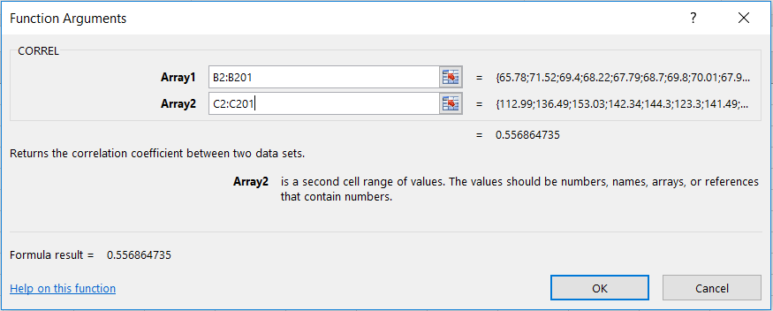

1. The result is

